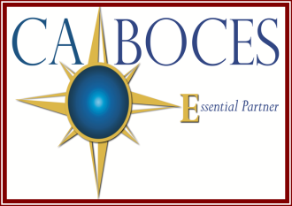

Day 1: August 15, 2018

Day 2: November 8, 2018

**Time:**

8:30 am – 2:30 pm

- Lunch will be provided

**Location:**

**Day 1: Olean Center Room C**

**Day 2: Olean Center -Barn**

1825 Windfall Rd.

Olean, NY 14760

**Registration:** Please have your district representative or Curriculum Coordinator register you at:

<http://register.caboces.org>

**NYS Teaching Standards:**

1. Knowledge of Students and Student Learning
2. Knowledge of Content and Instructional Planning
3. Instructional Practice

**COSER 529**

**Equal Opportunity Notice:**

CA BOCES hereby advises students, parents, employees and the general public that it offers employment, programs and educational opportunities, including career and technical education opportunities, without regard to gender, race, color, national origin, handicap or any other legally protected status. Inquiries regarding this nondiscrimination policy and grievance procedures may be directed to: Human Resources Director, Cattaraugus-Allegany BOCES, 1825 Windfall Road, Olean, NY 14760; 716-376-8237.

**Learning takes place when the teacher interacts with the student. Instruction must be focused on making that interaction most effective. Explicit Direct Instruction (EDI) is a collection of teaching procedures developed from decades of educational research. Teachers will leave this 2-day training understanding the components of EDI and how to strategically deliver well-crafted lessons that explicitly teach grade-level content to all students.**

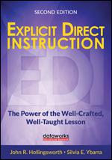

**Explicit Direct Instruction**

**K-12**