LOTE Teachers Classroom Resources workshop

Join us for a day of collaboration and learning with regional LOTE Teachers to explore resources available from our BOCES Learning Resources and Model Schools team.

We will explore the following:

- Castle Learning
- Foreign Language Apps
- Zoom
- Collaboration with other LOTE teachers

Who: Middle and High School Foreign Language Teachers
When: Tuesday, May 22, 2018
Where: CA BOCES Learning Resources at St. Bonaventure

Registration: 8:00AM
Workshop Time: 8:30AM - 2:30PM
Breakfast, refreshments, and lunch provided
Have your district contact person register you today! register.caboces.org

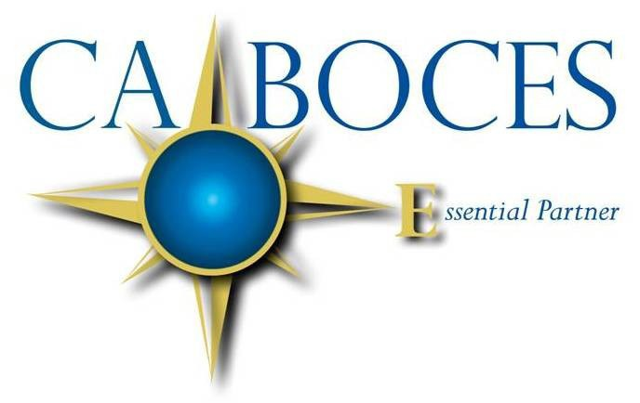
COSER 517
NYS Teaching Standards Addressed:
- Knowledge of Content and Instruction
- Learning Environment

Equal Opportunity Notice
CA BOCES hereby advises students, parents, employees and the general public that it offers employment, programs and educational opportunities, including vocational education opportunities, without regard to gender, race, color, national origin, handicap or any other legally protected status. Inquires regarding this nondiscrimination policy and grievance procedures may be directed to: Human Resources Director, Cattaraugus-Allegany BOCES, 1825 Windfall Road, Olean, NY 14760; 716-376-8237.

