Special Session
Grades 6-12 Math CLC

Join fellow educators from the region as we recap highlights from the
Association of Mathematics Teachers of New York State (AMTNYS) Annual Fall Conference and the
New York State Computer and Technology Teacher (NYSCATE) Annual Conference.

Teachers will share learning from the sessions they attended and learn from others that attended sessions from both conferences.

Time for collaboration and implementation of new strategies will be given.

Who: 6-12 Math Teachers, AIS, Special Education Teachers
When: December 20, 2017
Where: The Barn Training Room

Registration: 8:00AM
Workshop Time: 8:30AM - 2:30PM
Lunch Provided
Have your district contact person register you today!

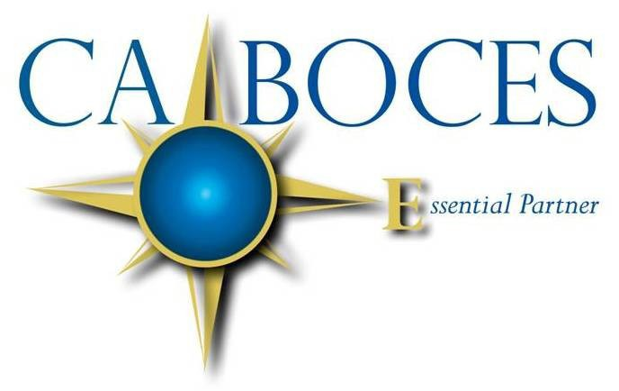
COSERS 529/517

NYS Teaching Standards Addressed:
• Knowledge of Content and Instruction
• Assessment for Student Learning

Equal Opportunity Notice
CA BOCES hereby advises students, parents, employees and the general public that it offers employment, programs and educational opportunities, including vocational education opportunities, without regard to gender, race, color, national origin, handicap or any other legally protected status. Inquires regarding this nondiscrimination policy and grievance procedures may be directed to: Human Resources Director, Cattaraugus-Allegany BOCES, 1825 Windfall Road, Olean, NY 14760; 716-376-8237.

