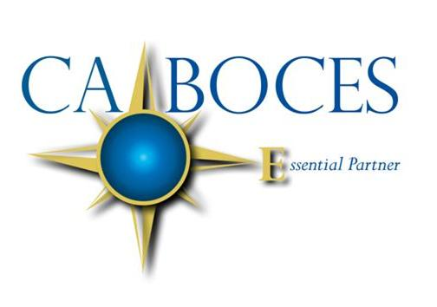
Digital Learning Day 2018
Come find your digital pot of gold!

Tools to explore
Friday, March 23, 2018
Hosted at the CA BOCES Olean Main Center Conference rooms 1, 2, and 3 in collaboration with Erie 2 BOCES
8:00am – 8:40am Introductions and morning refreshments
8:45am – 11:45am Vendor showcase
11:45am – 12:30pm Lunch
12:30pm – 1:30pm Teacher showcase of Moodle and Zoom
1:30pm – 1:45pm Debrief

The day will include:
- Presentations from online providers for credit recovery and credit accrual
- Explore digital tools to meet needs of students
- Discuss how teachers are using two digital tools in their classroom
- Time for your district team to discuss how digital learning will benefit your students
Have your district representative register you at: register.caboces.org

Equal Opportunity Notice
CA BOCES hereby advises students, parents, employees and the general public that it offers employment, programs and educational opportunities, including vocational education opportunities, without regard to gender, race, color, national origin, handicap or any other legally protected status. Inquires regarding this nondiscrimination policy and grievance procedures may be directed to: Human Resources Director, Cattaraugus-Allegany BOCES, 1825 Windfall Road, Olean, NY 14760; 716-376-8237.

