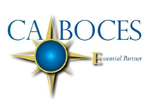
Library Automation for Mandarin Users
Facilitated by Alicia Thompson, Todd Catalano, & Gary Ciszewski from Erie 1  February 14, 2018  CA BOCES Main Center 1825 Windfall Road, Olean NY  Rooms 1, 2 & 3  12:00 – 2:00 Registration begins at 11:45  This information session will review two library automation programs supported by Erie 1. Current users of Mandarin will see demonstrations of Follett Destiny and OPALS to determine which software will work best for their school’s needs.  School librarians using Mandarin are invited, along with their technology directors and school building leader.  To register for this event, please have your curriculum coordinator or designated school official contact Laurie_Sledge@caboces.org  Equal Opportunity Notice: CABOCES offers employment, programs and educational opportunities without regard to gender, race, color, national origin, handicap or any other legally protected status. Inquiries regarding this nondiscrimination policy and grievance procedures may be directed to: Human Resources Director, CABOCES, 1825 Windfall Road, Olean NY 14760; 716-376-8200 | 